**ASSESSMENT TASK 1 COLLEGE OF SINGAPORE**

 **INDIVIDUAL TASK COVER SHEET**

|  |  |  |  |  |  |  |  |  |  |
| --- | --- | --- | --- | --- | --- | --- | --- | --- | --- |
| *Student*  *Please sign, date and attach cover sheet to front of assessment task for all hard copy submissions* | | | | | | | | | |
| **SUBJECT CODE** | CP2406 | | | | | | | | |
| **STUDENT FAMILY NAME** | **Student Given Name** | **JCU Student Number** | | | | | | | |
| Kumala | Jasson Didhi | 1 | 3 | 2 | 9 | 9 | 4 | 6 | 7 |
| **ASSESSMENT TITLE** | Assignment 1 | | | | | | | | |
| **DUE DATE** | 12 September 2017 | | | | | | | | |
| **LECTURER NAME** | Mr Kwang Lim | | | | | | | | |
| **TUTOR NAME** | Mr Kwang Lim | | | | | | | | |
| **Student Declaration**     1. This assignment is my original work and no part has been copied/ reproduced from any other person’s work or from any other source, except where acknowledgement has been made (see *Learning, Teaching and Assessment Policy*   *5.1*).   1. This work has not been submitted for any other course/subject (see *Learning, Teaching and Assessment Policy 5.9*). 2. This assignment has not been written for me. 3. I hold a copy of this assignment and can produce a copy if requested. 4. This work may be used for the purposes of moderation and identifying plagiarism. 5. I give permission for a copy of this marked assignment to be retained by the College for benchmarking and course review and accreditation purposes.       [Learning, Teaching and Assessment Policy](http://www.jcu.edu.au/policy/allitoz/JCU_076643.html) 5.1. A student who submits work containing plagiarised material for assessment will be subject to the provisions of th[e Student Academic Misconduct Requirements.](http://www.jcu.edu.au/policy/allitoz/JCUDEV_005375.html)    **Note definition of plagiarism and self plagiarism in Learning, Teaching and Assessment Policy:**  **Plagiarism:** reproduction without acknowledgement of another person’s words, work or expressed thoughts from any source. The definition of words, works and thoughts includes such representations as diagrams, drawings, sketches, pictures, objects, text, lecture hand-outs, artistic works and other such expressions of ideas, but hereafter the term ‘work’ is used to embrace all of these. Plagiarism comprises not only direct copying of aspects of another person’s work but also the reproduction, even if slightly rewritten or adapted, of someone else’s ideas. In both cases, someone else’s work is presented as the student’s own. Under the Australian *Copyright Act 1968* a copyright owner can take legal action in the courts against a party who has infringed their copyright.  **Self Plagiarism:** theuse of one’s own previously assessed material being resubmitted without acknowledgement or citing of the original.    **Student Signature**  **Jasson Didhi Kumala**  **…………………………………………………… Submission date 12/09/2017** | | | | | | | | | |

|  |  |
| --- | --- |
|  | **CP2406: Programming 2** |

Individual Task Cover Sheet (Version September 2016)

Analysis

|  |
| --- |
| Card |
| name: String |
| getName(): String |

UML

|  |
| --- |
| MainA1 |
|  |
| main(String[] args); void  playerInput(); void  deckInitializer(); void  playGame(); void |

|  |
| --- |
| STCard |
|  |
| function; String  cardDesc; String |

|  |
| --- |
| TrumpCard |
| hardness; float  gravity; float  cleavage; String  cleavageInt; int  crustal; String  crustalInt; int  eco; String  ecoInt; int |
| getCleavageInt; int  getCrustalInt; int  getEcoInt; int  getHardness; float  getGravity; float  getCleavage; String  getCrustal; String  getEco; String  convertCleavageInt; int  convertCrustal; int  convertEcoInt; int |

|  |
| --- |
| Player |
| hand; ArrayList<Card>  name; String  sc; Scanner |
| getName(); String  getCard(int x); Card  drawCard(Card card); void  getTurn(Table table); void  showAllCard(); String  startGame(Table gameStarter); void  checkWinningCard(); boolean  leaveGame(Table table); void |

|  |
| --- |
| Table |
| usedCard;ArrayList<Card>  deckCard;Deck  gamePlayers; ArrayList<Player>  cardMode; String  lastPlayerTurn; String |
| getCardMode(); String  getGameMode(); String  setCardMode(String cardMode); void  addBackCard; void  getPlayers(); ArrayList<Player>  getLastCard(); Card  anyCardPlayed(); boolean  getDeckCard(); Deck  playCard; boolean  putCard(Card card, Player play); boolean  getLastPlayerTurn(); String  setLastPlayerTurn(String lastPlayerTurn); void  playerGetTurnAgain(Player gamePlayer); boolean  setDeckCard(Deck deckCard); void |

|  |
| --- |
| Deck |
| cards; ArrayList <Card> |
| drawCard(); Card  getCards(); ArrayList<Card> |

User Story

* At start, user will be asked how many players that are playing
* User only can choose from 3, 4 and 5 players
* Then it will ask the player’s name
* Each player would then get 8 cards
* Then the game would start
* First player would choose what mode of game they would play
* Either Hardness, Specific Gravity, Cleavage, Crustal Abundance, and Economic Value
* Players would have to put a higher value than the previous card drawn from the mode chosen.
* If players do not have the card, they would have to pass.
* Players could also pass anytime they want
* This game will continue until there is one player left
* The players that has finished the card will leave the game
* The last player left is the loser

Testing

1. The user would be asked how many players

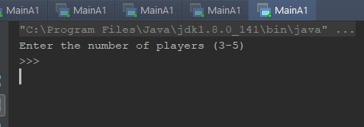

1. Players would be asked for their names

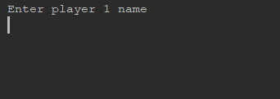

1. The first player would choose what mode they want to play

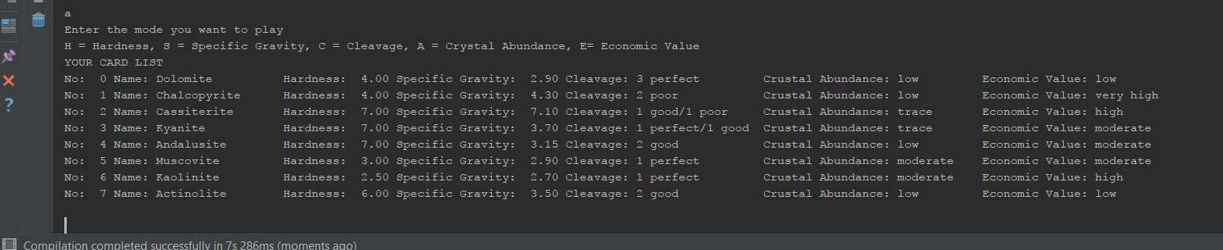

1. 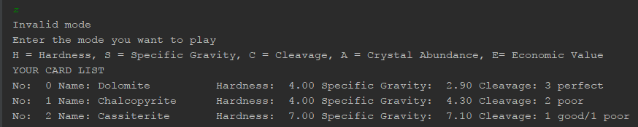If user tries to enter invalid mode
2. The player is then asked to choose which card they want to draw. The player would have to enter the card number.

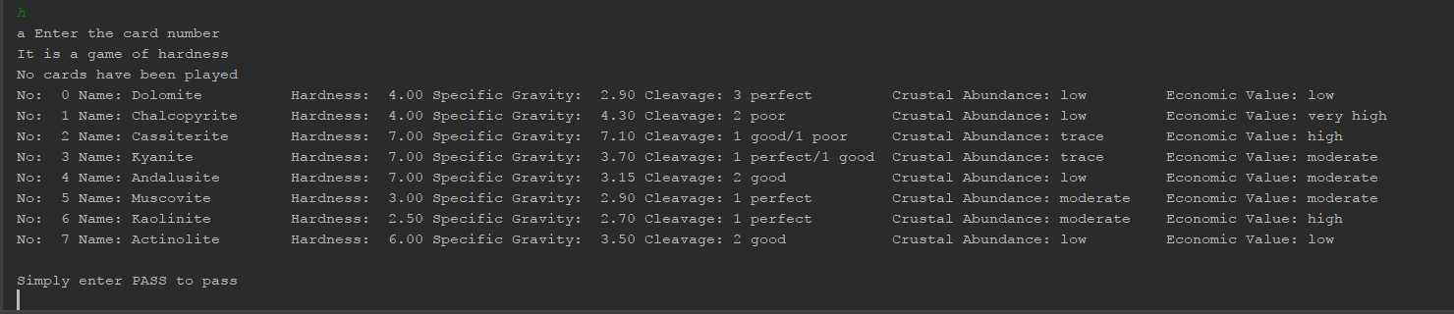

1. Player should draw the card which is higher than the previous card or it will give an error message
2. If player wants to pass just simply type pass

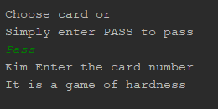

1. If all the players passed the last player who draw the card would be granted to choose a mode

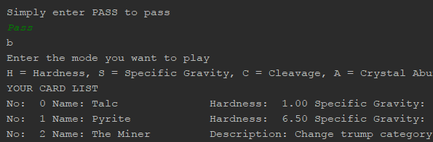

1. If a player draw a super trump card, it will automatically change the mode according to the super trump card

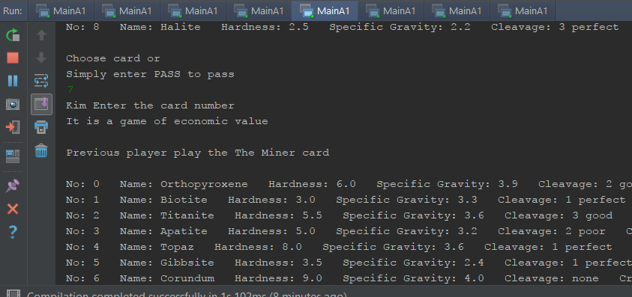

1. If a player has finished all their cards, they will leave the game

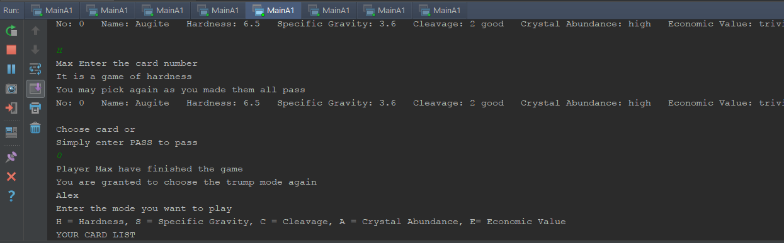

1. The last player in the game will lose

